# First Person Controller

Here is a tutorial on how to program a first-person controller from scratch, please note I am assuming you have read my previous tutorials and know “[ASB]” means ‘As Shown Below’. I hope you know what **Hierarchy**, **Assets** Folder and **Inspector** are in Unity too.

To make your life easier: Save your work after each step.

**Step 1**: Open **Unity** and load the scene that you want to edit, (I am assuming you already have a base “Ground” model with **Collider**)

**Step 2**: Right Click on your **Hierarchy** > **3D Object** > **Capsule** [ASB] This will be the player

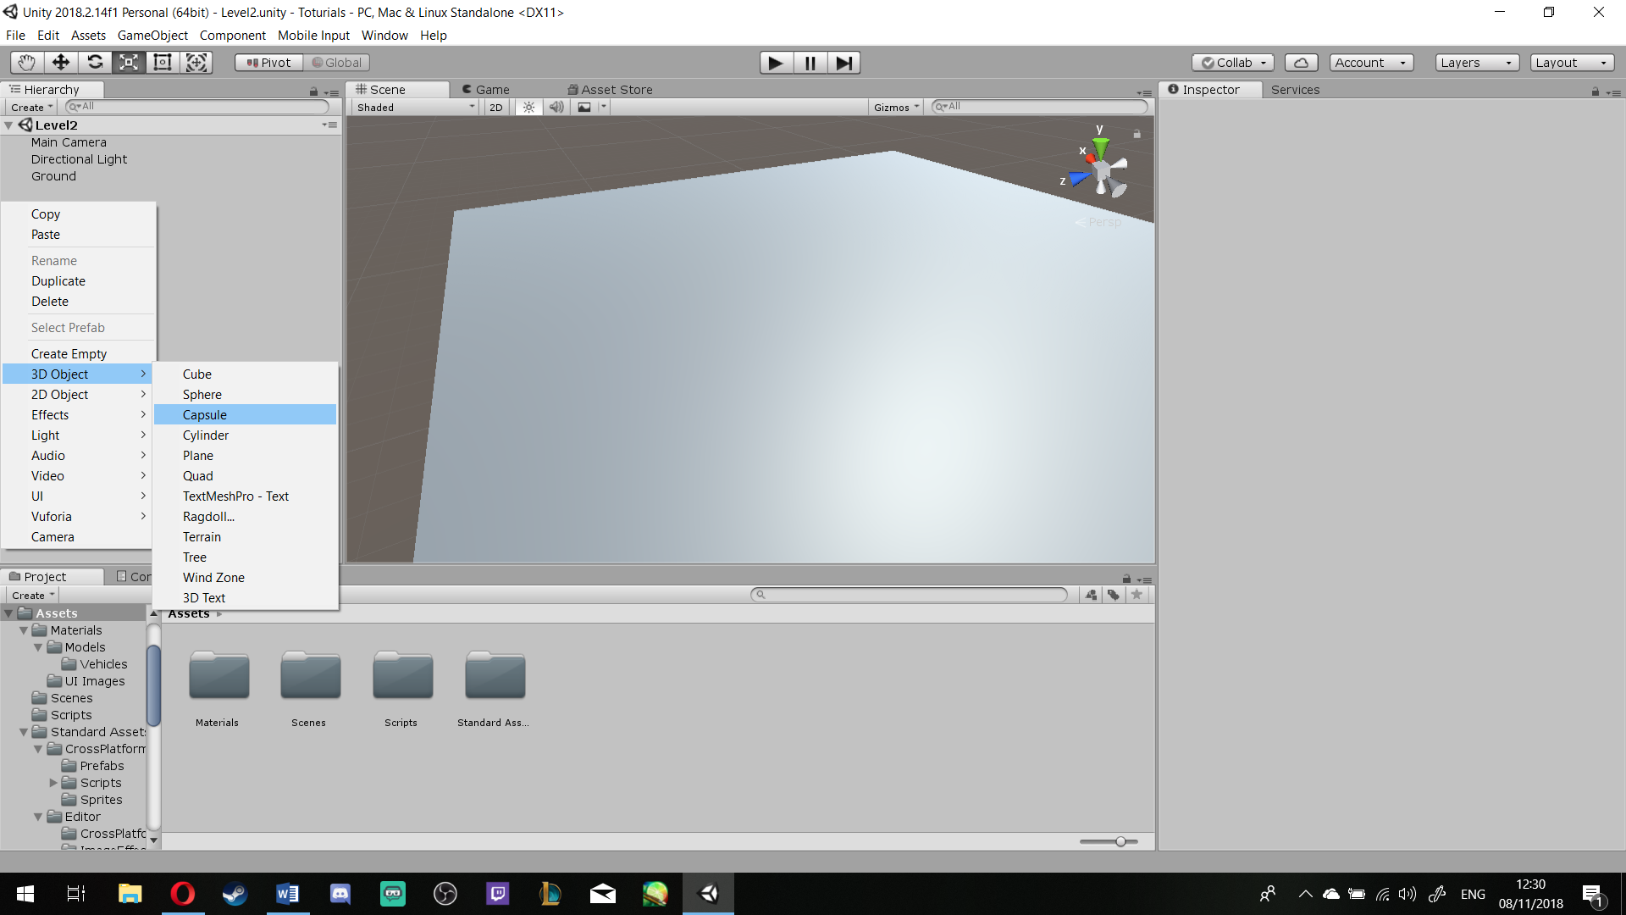

To make your life easier: Make sure it is above your ground and if you like, rename it to **Character** [ASB]

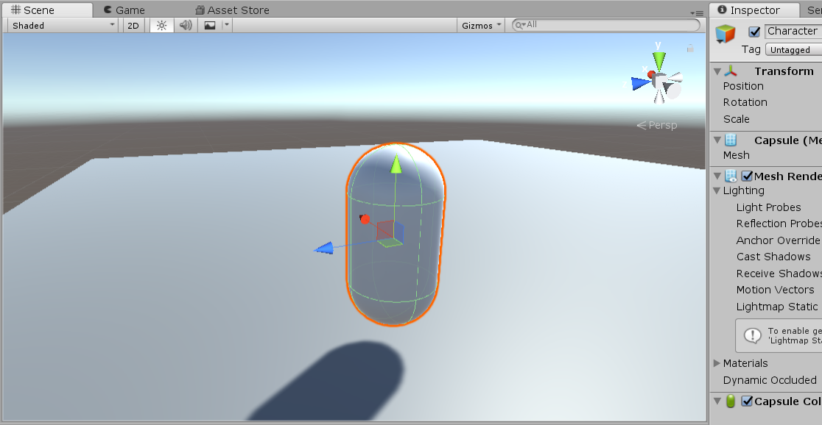

**Step 3**: Click on Character, under its Inspector, Add **Component** > **Rigidbody** [ASB]

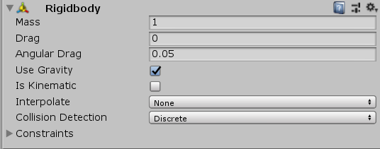

**Step 4**: Grab **Main Camera** in Hierarchy and Drop it onto **Character**, we want them to be connected [ASB]

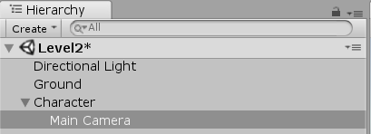

**Step 5**: Click on the **Main Camera**, change its **Position** to *X = 0, Y = 0, Z = 0* [ASB]



To make your life easier: Make a **Folder** in Your **Asset File** and call it **Scripts**.

**Steps 6**: Right Click in your **Scripts File** > **Create** > **C# Script** [ASB] and call it ***CharacterController***

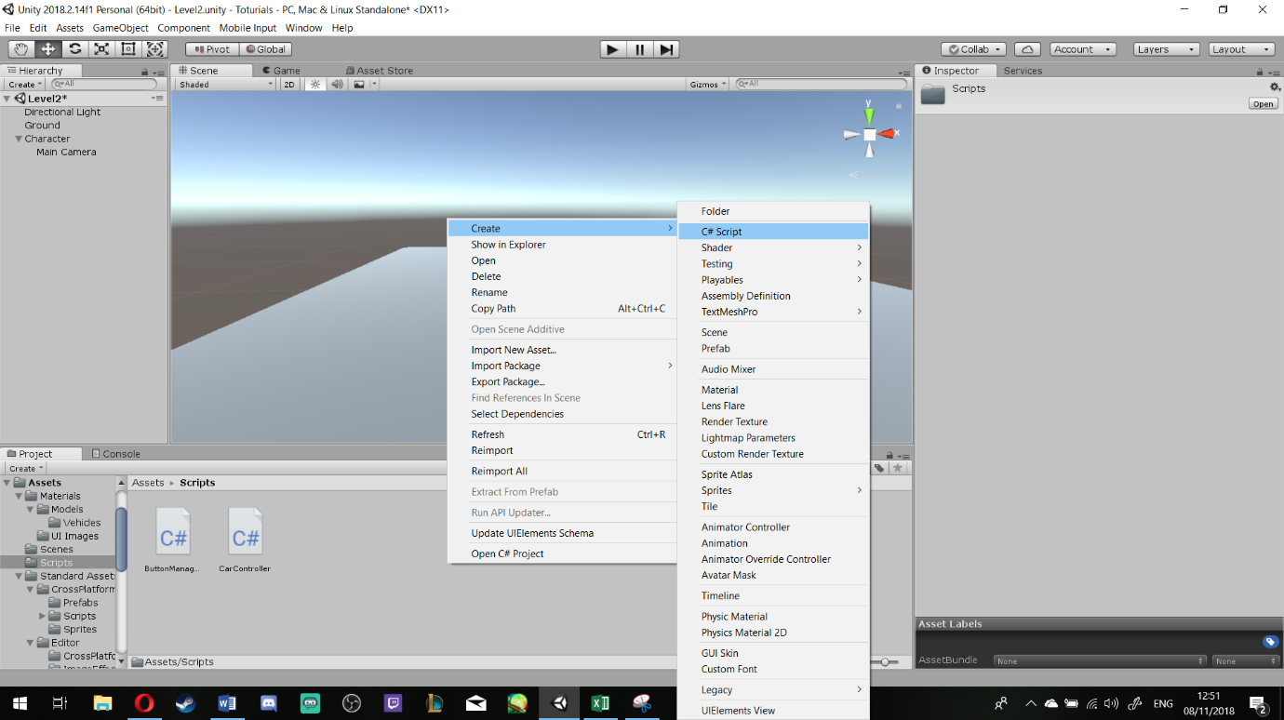

**Step 7**: Open the new created script, and write the following script: (pay attention to Comments, they explain the code for your better understandings:

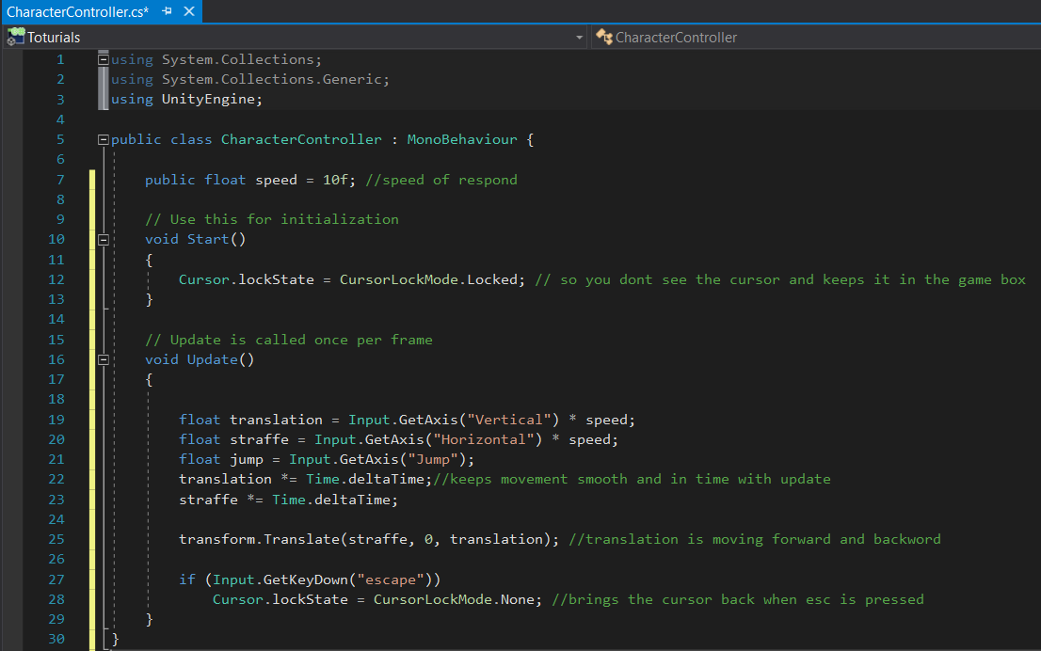

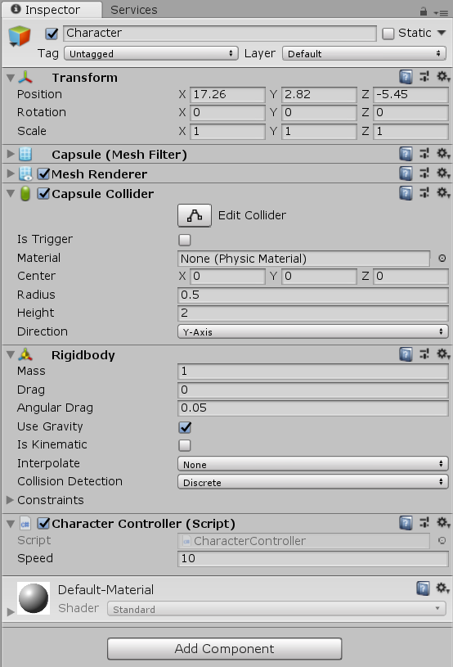**Step 8**: Save and go back to **Unity**, click on the **Character** and Drag and Drop the ***CharacterController*** Script on to Charater **Inspector**. [ASB]

**Step 9**: Select **Character**, look at the **Inspector**, under the **Rigitbody** > **Constraints** > Make sure Freeze Rotation X and Z are ticked [ASB]

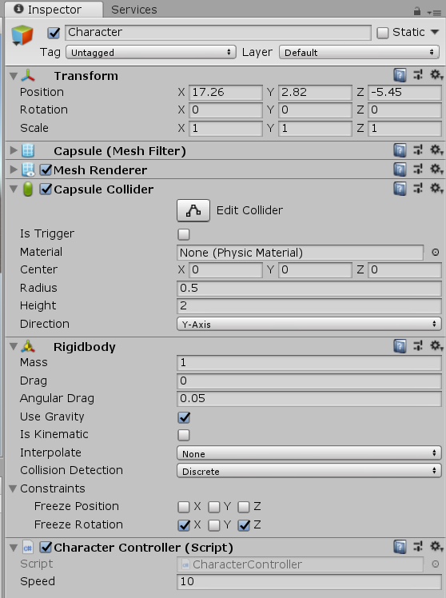

**Step 10**: Go to your **Script File** and Right Click > **Create** > **C# Script** and name it ***CamMouseLook***

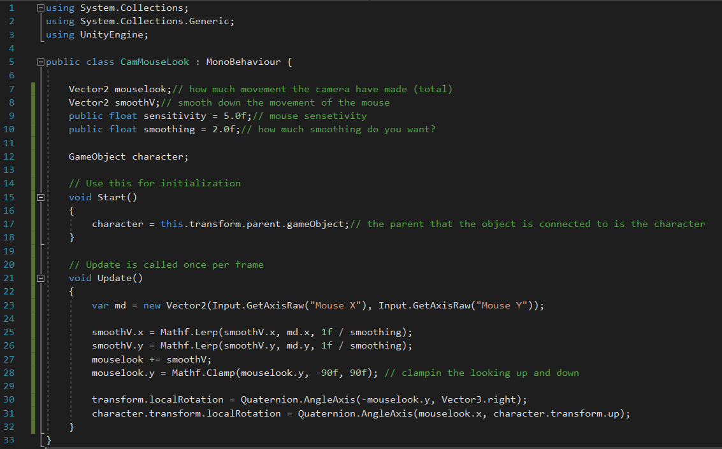**Step 11**: Open the **Script** to edit and add the following code:

**Step 12**: Save and go back to **Unity**, Drag the **Script** from the *Scripts Folder* and Drop it under the **Main Camera** [ASB]

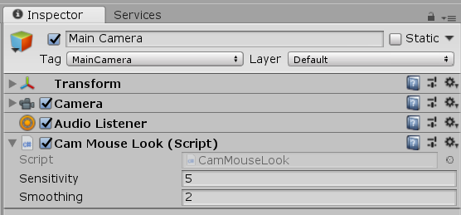

**Step 13**: Make sure you have **saved** your work and are ready to **move** around.